PRODUCT DETAILS

Casio Casio Collection Watch MWD-100H-1AVEF

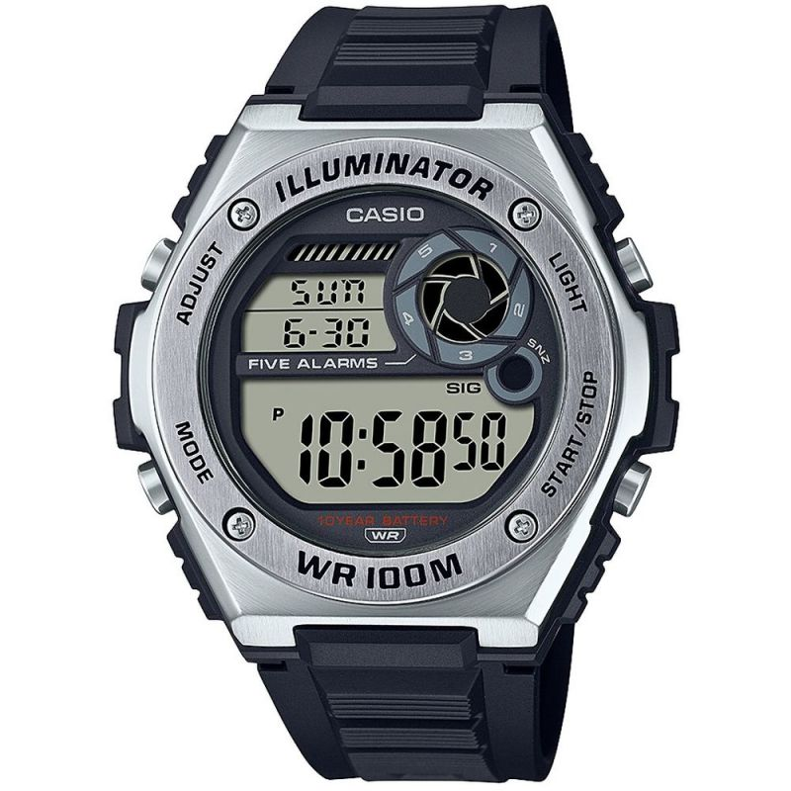

**£39.99**

**Specifications**

**Brand**: Casio

**Alarm**: Yes

**Analogue/Digital**: Digital

**Backlight**: Yes

**Case depth approx**.: 14.00mm

**Primary Material**: Stainless Steel

**Case Shape**: Circle

**Case width approx**.: 51.00mm

**Chronograph**: Yes

**Clasp type**: Strap buckle

**Dial Colour**: Black

**Multiple Time Zones Display**: None

**Gender**: Gents

**Glass**: Acrylic

**Luminescent hands**: Yes

**Model Collection**: Collection

**Model Name**: Collection

**Movement Source**: Japan

**Movement**: Quartz

**Strap colour**: Black

**Strap** **Type**: Plastic/Resin Strap

**Water Resistance**: 100 metres

**Weight (g):** 55.00

**BARCODE**: 4549526273308

**Guarantee**: 2 YEARS

**Country of Origin Code**: CH